ÇANKAYA UNIVERSITY – ECE DEPARTMENT – ECE 588
2016 Fall Term December 2016
Experiment 12 : Construction of 8 PSK, probability of error curves based on Xilinx blocks.
Experiment constructed from Matlab Simulink Xilinx blocks is given on course webpage with the names “PSK8_AWGN_Ric_Ray_Channel.mdl” and “CorrMHTE_ECE588.m”
- Download the model file and the m file from the course web page and start Matlab from “System Generator” icon. Open the model file, “PSK8_AWGN_Ric_Ray_Channel.mdl”.
- This experiment is for the construction of probability of error (P_{e}) curve for 8 PSK modulator (transmitter) and demodulator (receiver), based on Xilinx blocks and the lecture notes “Dimensionality of Signals_ASK_PSK_QAM_FSK_Jan 2013_HTE”.
- As seen from Fig. 1, the model file is arranged in the form of subsystems shown in while colour. Apart from the error “Error Rate Counting” and the “Display”, these subsystems are named, “Transmitter”, “Receiver” and “Noise Generator”. By double clicking on the subsystem, it is possible to see the constituents.
- After double clicking “Noise Generator” subsystem, you will see, the blue colured “AWGN” block. By again double clicking on that block, on the “Basic” tab menu, there will appear “wgn(1,131072,-22.54)” across “Initial value vector”. The present setting of -22.54 corresponds to SNR of 13 dB after subtracting -4.77 dB (due to bit energy being 10*log10(1/3) = -4.77 dB) and another -4.77 dB (noise sample covering one symbol duration, grouping three binary waveforms) from -22.54.
- This way, running the “PSK8_AWGN_Ric_Ray_Channel.mdl” file by incrementing -22.54 one by one down to -12.54, you will obtain in the first line of the “Display”, the probability of error values covering the SNR range of -3 to 13 dB. Write these values in an m file of Matlab and make the plot of P_{e} against bit SNR. Compare your curve with the Fig. 7.57 of Proakis 2002, which is pasted below as Fig. 2.
- To get ready for hardware co-simulation, modify “PSK8_AWGN_Ric_Ray_Channel.mdl” as shown in Fig. 3, by deleting the two scope inputs at the bottom, i.e. the outputs coming from the transmitter and multipath channel, name it “PSK8_AWGN_Ric_Ray_Channel_HWcosim.mdl”. Modify the “Initial value vector” of AWGN block to “wgn(1,65536,-22.54)” (because of memory limitation). Correspondingly set “Depth” of the same block to 65536. Then open the “Counter” by double clicking on it. From the popup menu, change “Count to value” to 65536, “Number of bits” to 16.
- Now connect the Virtex5 FPGA card to one of the USB ports of the computer. With the help of “Adept”, make sure that your computer communicates with the FPGA card. Return to the model file and press the System Generator icon, which is red coloured and in the shape of sigma. From the popup menu select Compilation → Hardware Co-Simulation → Virtex5, then press Generate at the bottom of the popup menu. It will some time, and if everthing is OK, you will get the message, “Compilation finished successfully”. In the end hardware co-simulation model will have been generated in a block of grey colour in another model file. Copy and paste this model file into the existing model file (you may rename it) and insert additional Error Rate Calculation and Display boxes (by copy and paste from above) and arrange the connetions as shown in Fig. 4.
- After setting the Simulation stop time to 1000000 (one million), press Start simulation (run) button at the top of the model file. During the run, if no errors are encountered, the red LED on the FPGA card will illuminate.
- At the end of the run, check that the two Displays Show approximately similar error rates. Recond these values on your exercise paper.
- In “PSK8_AWGN_Ric_Ray_Channel_HWcosim.mdl”, open “Multipath channel 3 paths” subsystem, change the “Constant value” to 0.3 in the block named “Constant”, and to 0.01 in the block name “Constant2”. This way, you will have included the effects of multipath channel. Repeat 7 to 9 of the above. Remember to replace the existing “PSK8_AWGN_Ric_Ray_Channel_HWcosim hwcosim” block with the newly generated one at the message “Compilation finished successfully”.
- Now make another run, by setting the Simulation stop time to 1000000 (one million). Compare the result of the Display with the one obtained in 9 and make the neceessary comments.
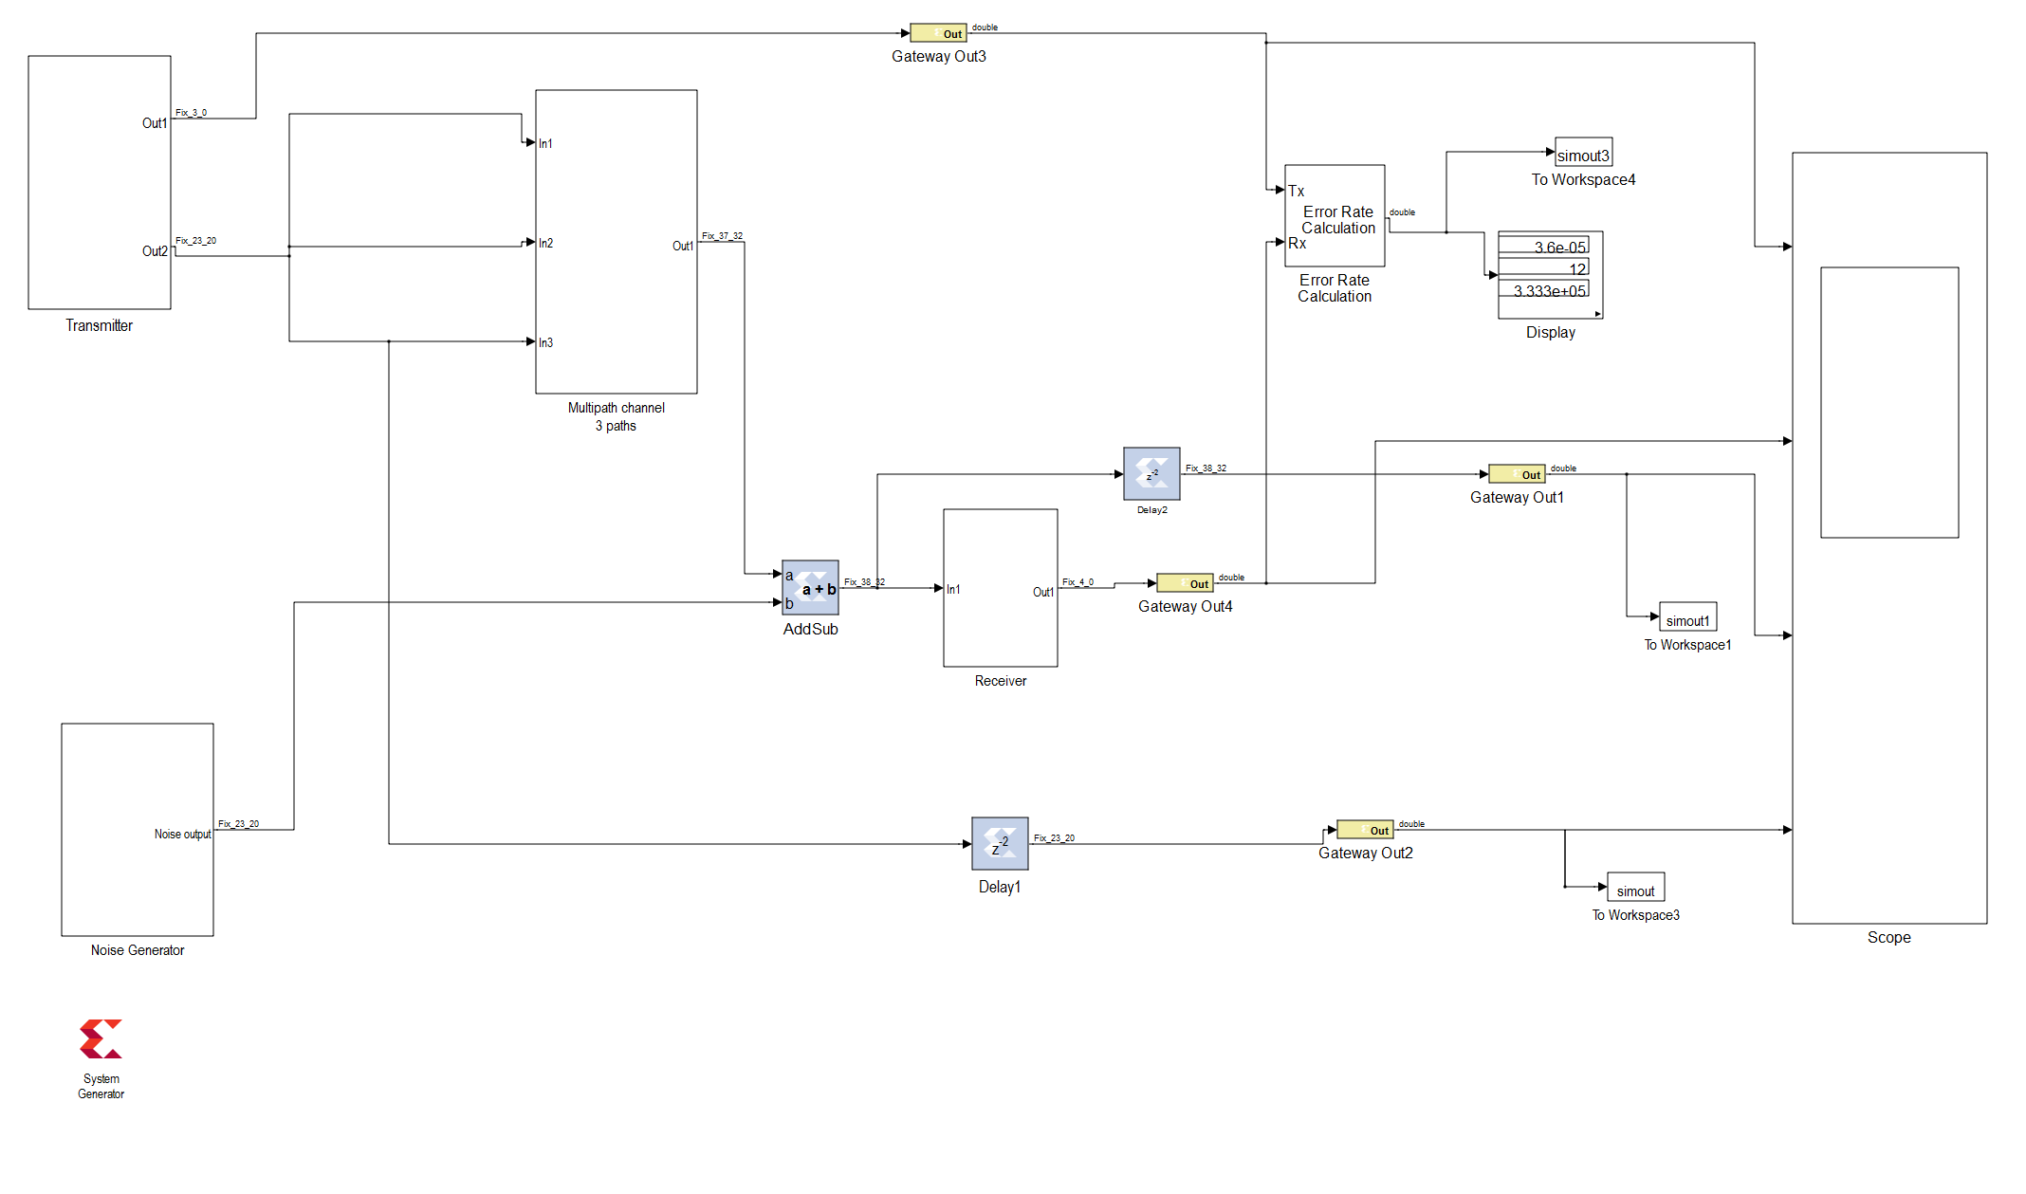
Fig.1 The model file “PSK8_AWGN_Ric_Ray_Channel.mdl”.
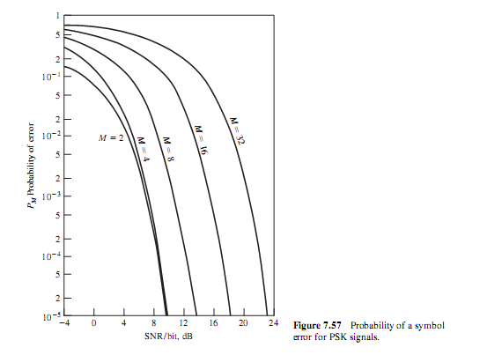
Fig.2 Probability of error curves in Fig. 7.57 of Proakis 2002.
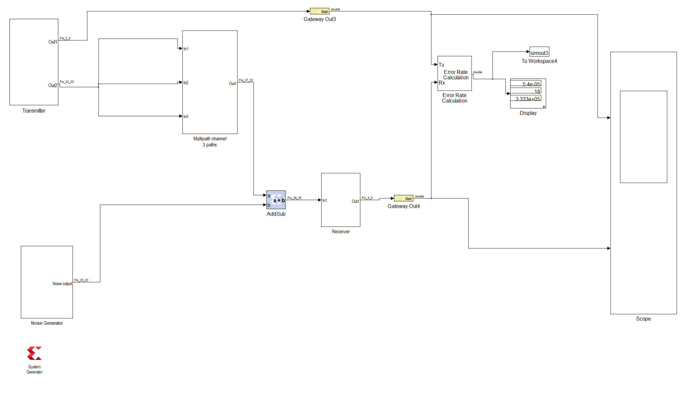
Fig.3 The model file “PSK8_AWGN_Ric_Ray_Channel_HWcosim.mdl”.
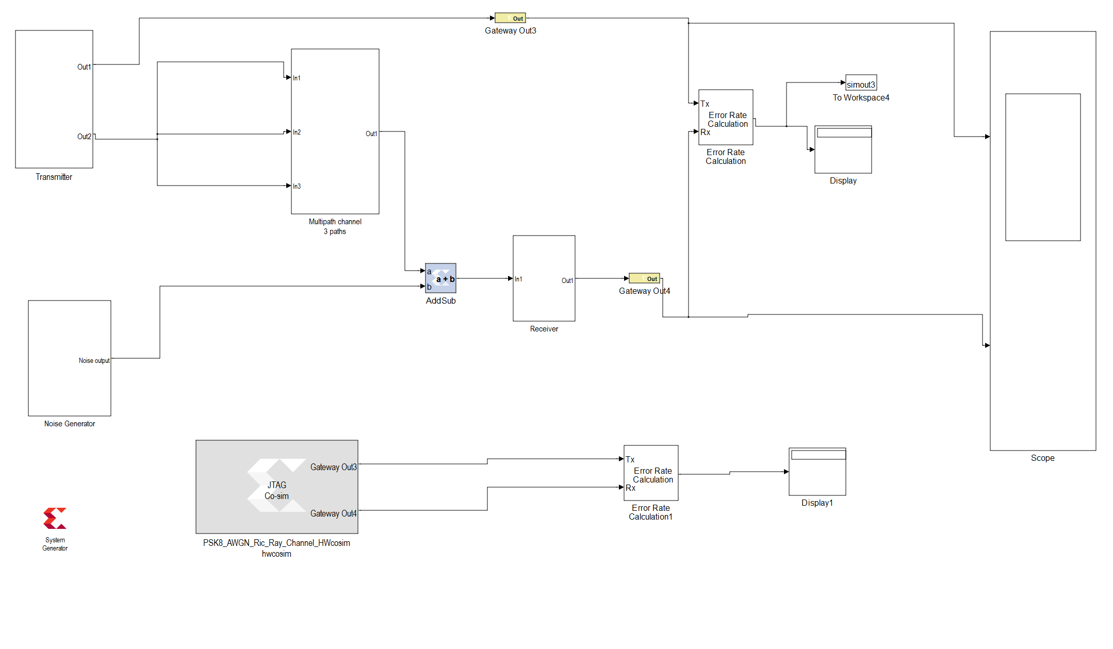
Fig.4 The appearance of model file “PSK8_AWGN_Ric_Ray_Channel_HWcosim.mdl” after the generation of the hardware co-simulation block.

